Business Need - Requirement Document (PRD)

Product Name: NewgenOne Prepared by: Yash Verma

1. What is the problem statement?

- Purpose: We want to hide specific data field while adding new data in mdm. The fields we want to hide are autogenerated and we don’t want users to add data to it. Although we can make them disable by selecting read only option from more properties (settings option) but we want those fields to be hidden. please suggest us how this can be achieved. Screen shots are attached for your reference.

2. Images in support of problem statement.
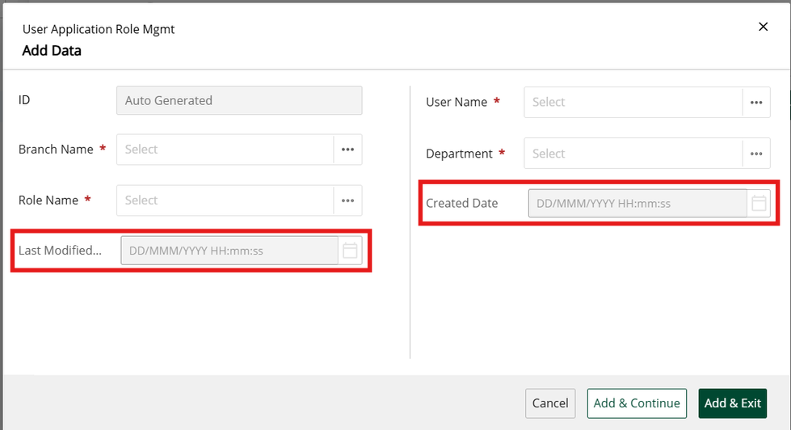

3. How is it achieved today?

NA

4. What is the solution, which is expected?

- Feature 1:

  - Description:
  - please suggest how can we hide the highlighted fields specifically.
  - or please provide us any hook so that we could hide it from our side.

5. Impact

If this will not be delivered: UI/UX will not be according to client needs.

If this gets delivered:

The user experience would be better.

6. Approval

Yes, I have discussed this with my leadership, and they have guided me to raise the requirement.

- Leader Name: Amitesh Bhusan Sharma

